TRADE OF PLASTERING

PHASE 2

Module 3
Slabbing, Skimming, Dry Lining and Floors

UNIT: 10

Floor Screeding

Produced by

In cooperation with subject matter expert:
Terry Egan
Some images & text courtesy of Gypsum Industries Ltd.
© SOLAS
Table of Contents
Introduction 1
Unit Objective 1
1.0 Interpreting and Drawing Sections of House Structure 2
1.1 Sections of House Structure 2
2.0 Interpreting and Drawing Oblique Projection of Foundation to Dpc Level 3
2.1 Foundation to Dpc Level 3
3.0 Estimating and Calculating Volumes of Concrete 4
3.1 Volumes and Areas of Sand/Cement and Concrete For Solid Floor Construction 4
3.2 Curing Concrete Floors 6

Introduction
Welcome to this section of your course which is designed to introduce you the learner, to interpret and draw sections, oblique projections and estimate volumes.

Unit Objective
By the end of this unit each apprentice will be able to:
- Interpret and draw sections of house structure
- Interpret and draw oblique projection of foundation to dpc level
- Estimate and calculate volumes of concrete

1.0 Interpreting and Drawing Sections of House Structure

Key Learning Points
- Sections through strip foundations, rising walls to dpc and solid floor construction

1.1 Sections of House Structure
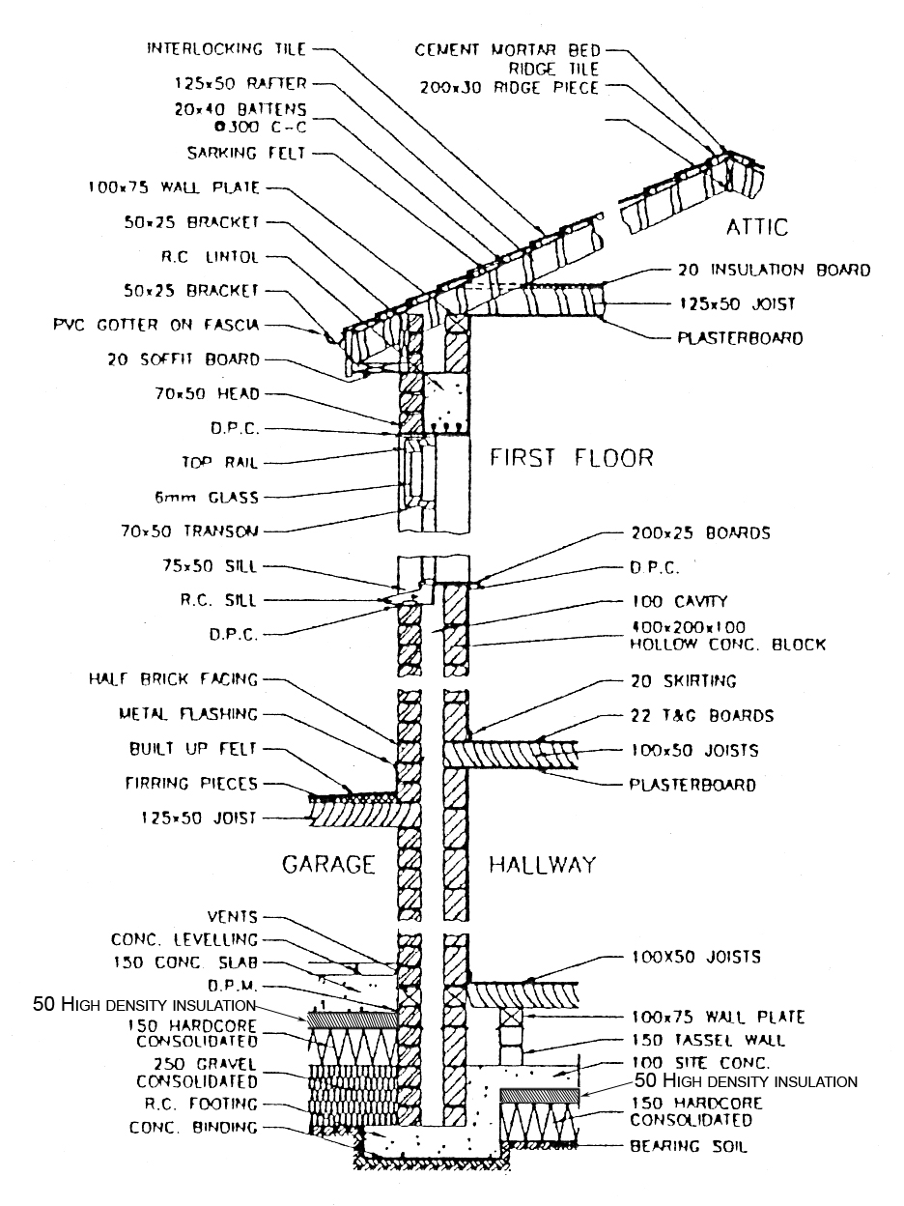

2.0 Interpreting and Drawing Oblique Projection of Foundation to Dpc Level

Key Learning Points
- Oblique projections of foundation to dpc level

2.1 Foundation to Dpc Level
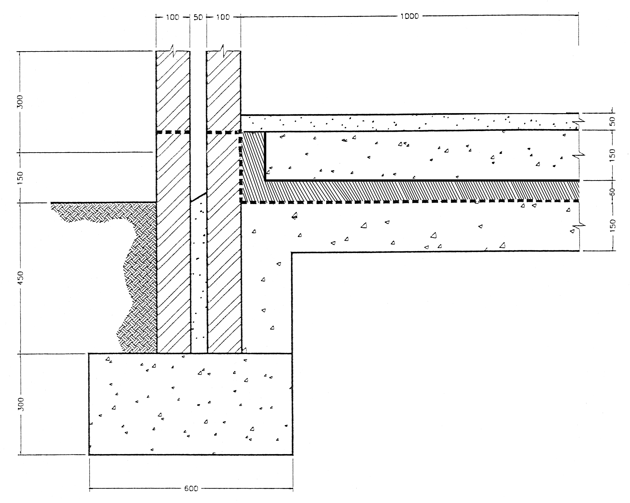

3.0 Estimating and Calculating Volumes of Concrete

Key Learning Points
- Volumes and areas of sand/cement and concrete required for solid floor construction
- Curing concrete floors

3.1 Volumes and Areas of Sand/Cement and Concrete For Solid Floor Construction
- 25mm cement and sand screed (1:3
- 50mm cement and sand screed (1:3
- Steel trowelled finish
- Finishing to falls or crossfalls
- 25mm granolithic bed (1:2½)
- 50mm granolithic bed (1:2½)
Note: Where access is difficult or where work is executed in narrow widths, i.e. 300mm wide, the following additions to the labour cost should be included.
- Work to staircase areas, ceilings and beams over 3.5m high and in compartments i.e. 4m² on plan +25%
- All work i.e. 300mm wide +30%
Example
A series of trenches 40 meters in total length have been excavated to a depth of 1 meter and a width of 750 mm as the footing of a new house. When removed the earth increased in bulk by 30%. The concrete and brickwork that make up the foundations will take up 48% of the trenches. How much of the earth should be removed from the site and how much should be retained for back filling.
Answer
Volume of earth to be excavated = 40m x 1m x 0.75m = 30m³
Bulking of 30m³ by 0.3 = 9m³
Volume of earth after bulking = 39m³
Area left in trench after completion = Area of trench -48%
48 % of 30m³ = 30m³x0.48 = 14.4m³
Volume of earth to be removed = 39m³ – 14.4 = 24.6m³
Example
Find the volume of a cold water tank with a base 1.5m x 0.9m and a height of 0.95m. Remember that height and depth mean the same thing for our purpose. Again the formula is L x W x D. Substituting the figures we get;
1.5x0.9x0.95 = 1.2825m³
The answer we arrived at is fine if we intend to fill the tank with concrete, sand or anything else we buy in cubic metres, but often when dealing with volumes we require more than the capacity. So let’s look briefly at a few of the physical characteristics of water.
A cubic metre of water contains 1,000 litres. A litre of water has a mass of 1 kg. Therefore, 1,000 litres of water has a mass of 1,000 kg or one metric tonne.
We know that 1m3 of water contains 1,000 litres and has a mass of 1,000 kg; we also know the volume of our tank in cubic metres. To find how many litres of water and the mass of the water in the tank we multiply the volume of the cistern by 1,000.
Water held in tank = 1.2825 x1,000 = 1282.5 litres
And as 1 litre of water has a mass of 1 kg,
Mass of water held in tank = 1282.5kg or 1.2825 tonnes

3.2 Curing Concrete Floors
Concrete gradually hardens and gains strength after its initial set. For this hardening process to proceed and the concrete to develop its maximum strength there must be water present in the mix. If, during the early days after the initial set, there is too rapid a loss of water the concrete will not develop its maximum strength. The process of preventing a rapid loss of water is termed curing concrete. Large exposed areas of concrete such as road surfaces are cured by covering the surface for at least a week after placing, with building paper, plastic sheets or wet sacks to retard evaporation of water. In very dry weather the surface of concrete may have to be sprayed with water in addition to covering it.
The formwork around reinforced concrete is generally kept in position for several days after the concrete is placed in order to give support until the concrete has developed sufficient strength to be self supporting. This formwork also serves to prevent too rapid a loss of water and so helps to cure concrete. In very dry weather it may be necessary to spray the formwork to compensate for too rapid a loss of water.

27-33 Upper Baggot Street
Dublin 4

